SIMATS ENGINEERING

ASSESSMENT TOOL 2

COURSE NAME: Cryptography and Network Security COURSE CODE: CSA5116

COURSE OUTCOME COVERED

CO1: Apply classical encryption techniques using symmetric and asymmetric ciphers to encrypt and decrypt data for the ensuring data security. (BL3, BL4)

Assessment Tool Weightage: 20%

QUESTIONS: 5 Total Marks:50

Annexure A

CONCEPT MAPPING

Code of Conduct:

I Y.Naga Tharuni(192372338) certify that this submission is my original work and that I have adhered to the guidelines specified for this assessment.
I understand that any violation of academic integrity rules will result in disciplinary action.

Signature of the student:Y.Naga Tharuni

RUBRICS FOR CALCULATION:

Criteria | Weight  a ge | Level 4 –  Exemplary | Level 3 –  Proficient | Level 2 –  Developing | Level 1 –  Beginning

Understandi ng of Concepts | 25 | Demonstrates thorough understanding and effectively integrates multiple concepts/technolo  gies | Good understandi ng with proper integration of most concepts | Basic understandin g; limited or partial integration | Poor understandin g; unable to integrate concepts
Experiment al Design | 30 | Well-planned, systematic implementation with optimal  solution | Correct implementat ion with minor issues | Basic implementati on with errors or inefficiencies | Incorrect or incomplete  implementati  on
Use of Tools | 20 | Effective and advanced use of tools/technologies with proper  configuration | Appropriate use of tools with correct execution | Limited or inconsistent use of tools | Incorrect or minimal use of tools
Analysis of Results | 15 | Insightful analysis with accurate interpretation and validation of results | Good analysis with reasonable interpretatio  n | Basic analysis with limited insights | Poor or incorrect analysis of results
Documenta t ion | 10 | Clear,  well-structured documentation with diagrams, code, and results | Organized documentati on with necessary details | Basic documentatio n with missing  details | Poor or incomplete documentatio n

Annexure A

CONCEPT MAPPING

1.Develop a concept map comparing substitution techniques: Caesar Cipher, Monoalphabetic Cipher, Vigenère Cipher and Hill Cipher. Perform the following tasks to connect based on: Key usage, Complexity and Security strength. Analyze which technique is most secure and why.

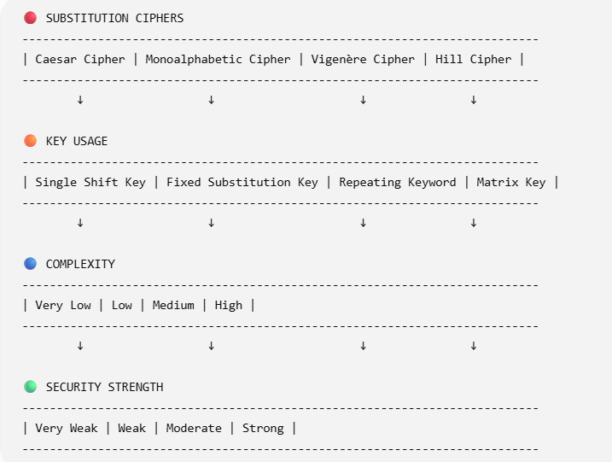
EXPLANATION
1. Caesar Cipher
  - Key Usage: Single shift (e.g., +3)
  - Complexity: Very low
  - Security: Very weak
  - Reason: Easy brute force (only 25 possibilities)
  - Example: A → D
2. Monoalphabetic Cipher
  - Key Usage: Fixed letter mapping

Complexity: Low
  - Security: Weak
  - Reason: Frequency analysis can break it
  - Example: A → Q, B → W
3. Vigenère Cipher
  - Key Usage: Repeating keyword
  - Complexity: Medium

  - Security: Moderate
  - Reason: Multiple shifts reduce frequency attack
  - Example: Key = “KEY”
4. Hill Cipher
  - Key Usage: Matrix (linear algebra)
  - Complexity: High
  - Security: Strong
  - Reason: Uses mathematical transformations, harder to break
  - Example: 2×2 or 3×3 matrix encryption

ANALYSIS

✅ Most Secure Technique: Hill Cipher
✔ Why?

Uses matrix multiplication
  - Encrypts multiple letters at once
  - No simple frequency patterns
  - Large key space → difficult to brute force

FINAL COMPARISON LINE

Caesar < Monoalphabetic < Vigenère < Hill (Increasing Security)

2.Construct a concept map for Classical Encryption Schemes: Substitution Techniques and Transposition Techniques. Perform the following tasks:
- Show differences and similarities
  - Map how each affects the Data structure and Security level
  - Analyze which is more vulnerable to attacks and why

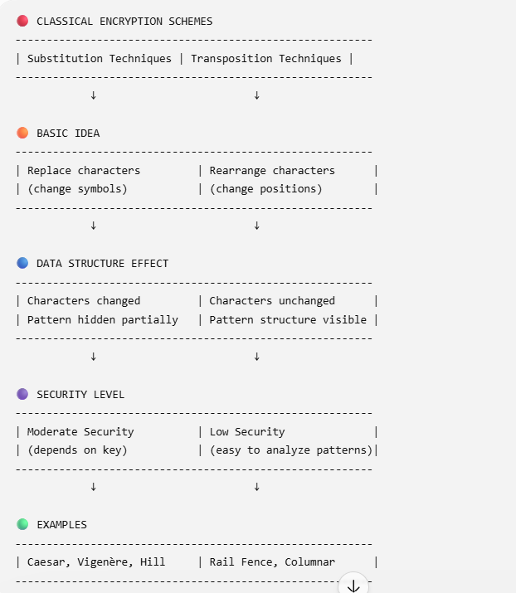

SIMILARITIES

- Both are classical encryption techniques
- Both use keys for encryption/decryption
- Both aim to protect data confidentiality
- Both are vulnerable to modern cryptanalysis DIFFERENCES
Feature | Substitution | Transposition
Method | Replaces letters | Rearranges letters
Data Change | Changes symbols | Keeps symbols same
Pattern | Partially hidden | Often visible
Security | Higher | Lower

ANALYSIS

❗ More Vulnerable Technique: Transposition Cipher
✔ Why?
- Does not change characters, only positions
- Original letter frequency remains same
- Easy to break using pattern analysis & anagrams

✔ Substitution (Less vulnerable than transposition)
- Changes characters → hides original data
- But still breakable using frequency analysis

FINAL CONCLUSION
Transposition is more vulnerable than Substitution because it preserves original data patterns.

3.Create a concept map connecting Stegnpgraphy Concepts:Data Hiding,
Watermarking and Survivability. Perform the following tasks:
- Show relationships between these concepts
- Analyze how each contributes to secure communication
- Include one real-world application for each

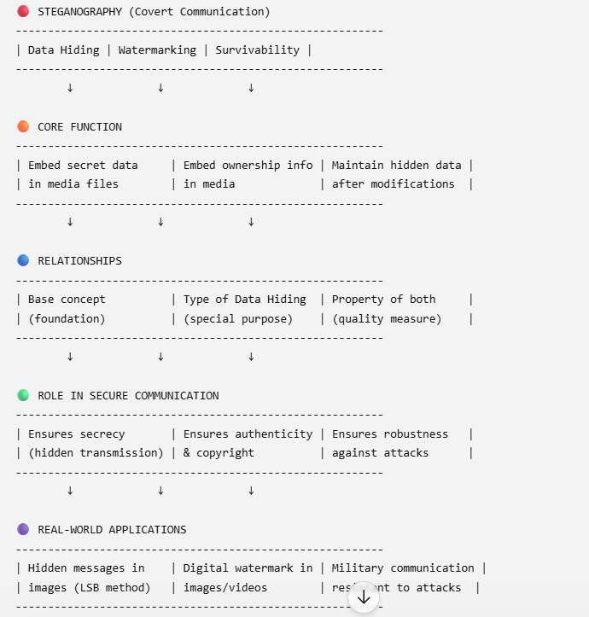

RELATIONSHIPS
Data Hiding → Main technique
Watermarking → Specialized form of Data Hiding Survivability → Strength/quality of both techniques

CONTRIBUTION TO SECURE COMMUNICATION

Data Hiding

    - Hides existence of communication
    - Prevents attackers from detecting message
    - 👉 Provides confidentiality

Watermarking

    - Embeds ownership/identity into data
    - Helps detect unauthorized usage
    - 👉 Provides authentication & integrity

Survivability

    - Ensures hidden data is not destroyed
    - Resistant to compression, cropping, noise
    - 👉 Provides robustness & reliability

REAL-WORLD APPLICATIONS

- Data Hiding: Secret communication using images (covert messaging)
- Watermarking: Copyright protection in movies, photos, music
- Survivability: Military or forensic data that must survive attacks

FINAL ANALYSIS

Secure Communication = Secrecy (Data Hiding) + Authenticity (Watermarking) + Robustness (Survivability)

4.Draw a concept map linking number theory concepts used in cryptography: Modular Inverse, Extended Euclid Algorithm, Fermat’s Little Theorem, Euler’s Phi Function and Euler’s Theorem. Perform the following tasks:
- Show how each concept is mathematically connected
- Map their role in encryption/decryption
- Analyze which concept is most critical for public key cryptography and justify
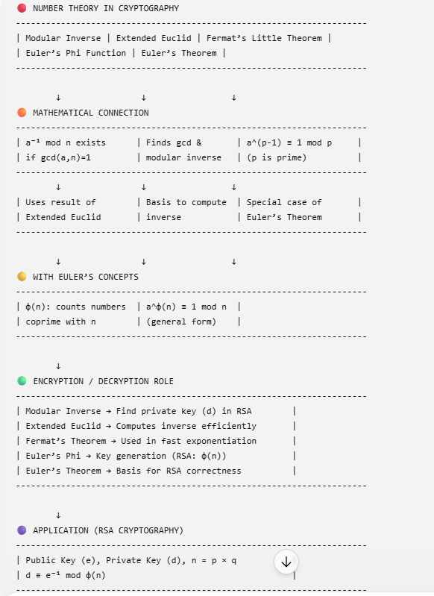

MATHEMATICAL CONNECTIONS
Extended Euclid → computes gcd & Modular Inverse

Modular Inverse → exists only if gcd(a,n)=1
Euler’s Phi → used in Euler’s Theorem
Euler’s Theorem → generalization of Fermat’s Theorem Fermat’s Theorem → special case when n is prime

ROLE IN ENCRYPTION / DECRYPTION

Modular Inverse

  - Used to compute private key (d)
  - Critical in RSA:
👉 d ≡ e⁻¹ mod φ(n)

Extended Euclid Algorithm

  - Efficient way to find:

    - gcd
    - modular inverse

Used in key generation Fermat’s Little Theorem
  - Simplifies modular exponentiation

Helps in encryption/decryption speed Euler’s Phi Function (φ(n))
  - Counts coprime integers

Used in RSA key generation Euler’s Theorem
  - Mathematical foundation of RSA
  - Ensures:
👉 Decryption recovers original message

MOST CRITICAL CONCEPT
Most Critical: Euler’s Phi Function (φ(n))

✔ Justification:
  - Required to generate RSA keys
  - Used to compute modular inverse (private key)
  - Without φ(n), encryption/decryption cannot work properly FINAL ANALYSIS
  - Extended Euclid + Modular Inverse → Key computation
  - Euler’s Phi + Euler’s Theorem → RSA foundation
  - Fermat → optimization
👉 Together, they ensure secure and correct public key cryptography

